FDI: Murphy Wallbed Company Entering Thialand

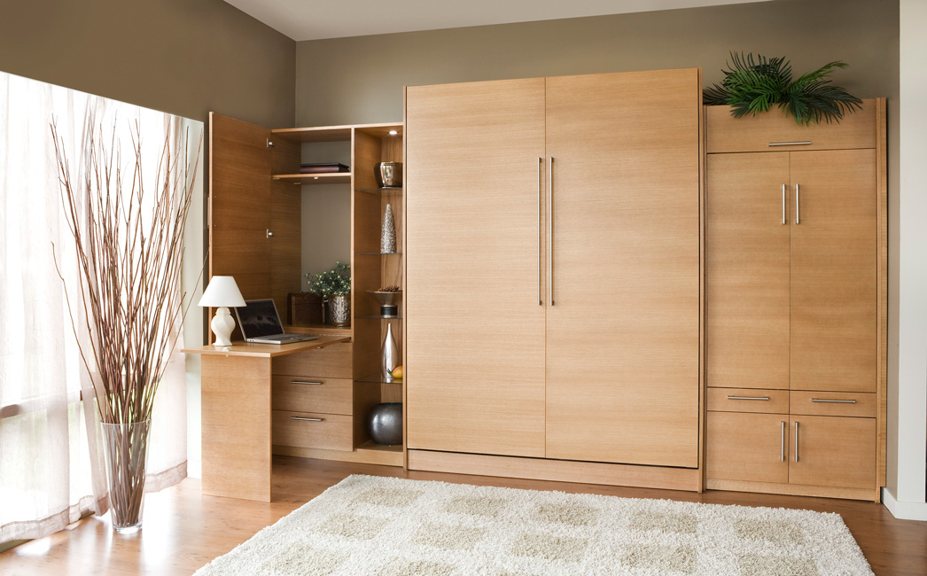
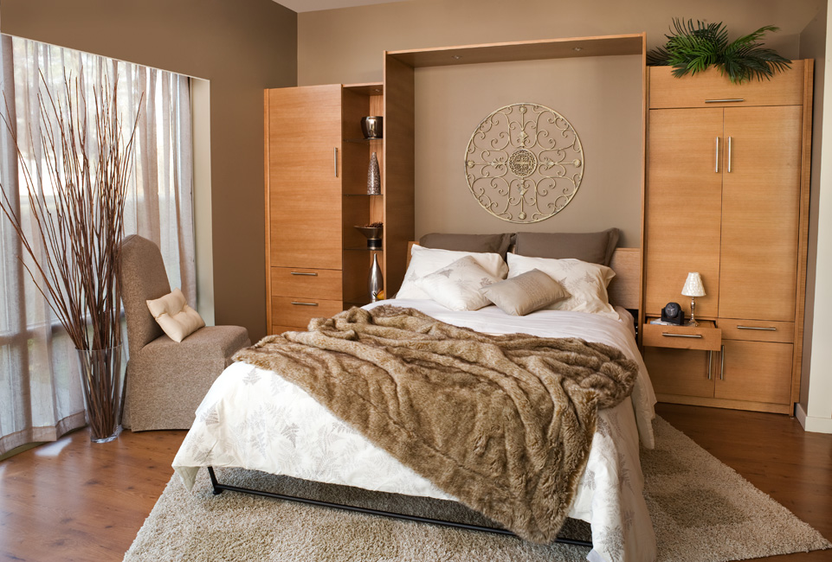

Meghan Nelson and Emma Anderson
Submitted in May 2014
Globalization: Business Implication
Professor: Rajeev Sooreea

Executive Summary
Thailand’s political economy and culture afford our company great ease of doing business. The country’s democratic governance has reduced the amount of political risk in market entry to an acceptable level. Thailand’s civil law legal system assists our company by providing ample protection of intellectual property rights, reducing Alien Business Law restrictions on business ownership for U.S. nationals, and creating demand for mass production of the resources which make up the majority of our furniture. Thailand’s strong growth rate and relatively high standard of living measures demonstrate the readiness of Thailand for our product. Generally, Thai culture will be advantageous for our company. However, hurdles may arise with regard to ethical implications. Murphy Wall-Beds Hardware, Inc. must work hard to uphold a high ethical standard within this country, in which corruption is the most problematic factor of doing business.
After establishing the readiness of the Thai market for Murphy Beds, we consider how to maintain our core competency in this country. We offer high-value goods at low-cost with superior customer service through a high level of vertical integration; we oversee production, marketing, sales, distribution and installation of our Murphy Beds. To translate this competency to Thailand will require an entry mode of Greenfield FDI (transportation costs and need for trained installation teams rule out exporting). We will maintain control over every step in the producer-to-consumer chain while keeping costs relatively low. There are disadvantages to this entry strategy, including high start-up costs and high risks associated with investing directly in a foreign country. Although currency exchange fluctuation can be problematic, our risks are minimized as both costs incurred and revenues created will be in Thai Baht.
One final consideration to be made is the business strategy for introducing our product. Murphy Wall-Beds Hardware, Inc. is a first mover in this niche product market, so cost reduction pressure from competition is non-existent. However, our target market’s income level makes cost reduction necessary. Redesign of our product is avoidable because the Murphy Beds that we offer satisfy universal urban needs. With high cost reduction pressure and low pressure for local responsiveness, Murphy Wall-Beds Hardware, Inc. will take a global standardization strategy approach in the Thai market. Ergo, the return on our investment will outweigh the costs we incur.

Product Offering and Target Country
Ideal for urban living, murphy beds provide the perfect blend of function and beauty. Murphy Wall-Beds Hardware, Inc. (MWBH) manufactures, markets, sells, and installs high-quality, low-cost murphy beds that fit any style. These beds are anchored to the wall and can be hidden away behind faux cabinet doors when extra square footage or room functionality is desired. The beds come in a variety of sizes and can be paired with a number of cabinet/couch designs to meet a customer’s specifications. While MWBH has grown its domestic market share, the company is now looking abroad for new clients whose furnishing needs are not being met by traditional furniture dealers. We propose that opening a new location in Thailand will give MWBH access to new clients, opportunities to learn how to operate in an emerging market, and global brand recognition growth.
The decision to bring MWBH to Thailand is rooted in the relationship between what the consumers of Thailand need and the products that MWBH can provide. Though Thailand’s population growth has recently began to decline, the percentage of its population in the densely packed major cities is 34.1 and continues to rise at 1.6 percent per year (“Thailand” CIA: The World Factbook 2014). In cities like Bangkok, industries rely heavily on this large, highly concentrated labor force. While the average number of persons per household had decreased to 3.2 in 2010 (National Statistics Office, Thailand, 2010), in densely populated areas families of this size must generally remain in two-bedroom layouts. Installation of Murphy beds within a home allows versatility and dual applications in room usage through simple and aesthetically pleasing methods, so that a family can reside in small living quarters without feeling as though they are losing space. One final preliminary consideration of the market for wall beds in Thailand is the population age structure. The majority of Thai citizens fall between the ages of 15 and 60 years of age (Figure 1.1) and MBWH can realize marketing opportunities throughout this age spectrum. Our products and services can be marketed to the aspirational spending patterns of young adults in this emerging market, the practicality of middle-aged adults, and the downsizing needs of the older adult population. Market factors in Thailand provide an ideal setting for the expansion of MWBH’s first international venture.
While demand for wall beds in Thailand is present, MWBH’s investment would not be sound if it were not also cost effective and sustainable. To determine what costs this venture will incur in the most general sense, we began by looking at our basic expenses: materials for production and transportation of those materials. The four main materials used in constructing a wall bed are particle board, MDF (medium-density fiber) board, ply wood, and solid wood (“Murphy Bed Buyers Guide” 2012). Importing these materials or pre-fabricated beds to Thailand would be too expensive to provide our beds at a reasonable price for Thai consumers, so these resources must be available in the host country. Currently, due to the depletion of natural sources of large-diameter wood, Thailand has greatly increased investment in research and production of MDF resources. "Their [MDF products] greatest advantage is that low quality and low value raw materials (including non-wood fibers) which can be turned into high value and high quality wood-panels." (Food and Agriculture Organization) These necessary materials are not only abundant in Thailand, but are cheap because of their surplus. Capitalizing on the ready availability of materials for production, MWBH’s operations can achieve cost effectiveness. The low-price, high-quality, and space-saving household product MWBH will give the company a competitive edge in the Thai market.

Political Economy
To begin doing business in Thailand we must first become familiar with the market’s composition by understanding the interplay of its political environment, legal system, and economic context.
- Political System:
  - Government type: Constitutional monarchy
  - Key political systems: Constitutional institutions & royal family
(“Thailand: Government” 2014).
- Capital City and Financial Center: Bangkok
- Political Risk History:
  - Democracy (since 1992)
  - Period of political disruption in 2006 when military junta staged a coup
  - Power transitions smooth since 2007
  - King has maintained position since 1946 and remains a stabilizing factor in the government
(“Thailand: Government” 2014)
- Legal System: Thailand follows a code of laws by practicing a civil law judicial system that has some common law influences from neighboring developed countries.
  - Intellectual Property Rights (IPR): Specialty courts (i.e. the Central Intellectual Property and the International Trade Court) which show Thai recognition of IPR importance and they strictly enforce IPR laws (Triamanuruck, Phongpala, and Chaiyasuta 2004)
  - Alien Business Law (ABL): Restricts operations of foreign investors and limits exporters (“Thailand Market Profile” 2013)
  - Treaty of Amity and Economic Relations: Exempts the United States from many restrictions under the ABL, and all of MWBH’s raw materials and business practices are acceptable for foreign business partners from the U.S. (“Thailand Market Profile” 2013)
- Economic Context: Mixed economy, which relies heavily on exports
- GDP per capita (use PPP measure): $5,840
  - Total GDP: $336 billion (0.78% of world total) (Figure 2.1)
  - Growth Rate:
    - Averaged at 8-9% in early 1990s
    - Decreased during the Asian Crisis (1997-1998)
    - Grew to reach nearly 5% growth rate by 2007
(World Bank 2014)
- Population:
  - Size: Nearly 66.8 million persons
  - Growth rate: 0.3% (2012) (Figure 2.2) (World Bank 2014)
  - Age Structure: (see Figure 2.3)
- Labor Force:
  - Efficiency: Ranks 62nd in world (see Figure 2.4 for breakdown) (World Bank 2014)
  - Sectors: Services (48.2%), Agriculture (38.2%), and Industry (13.6%). (Figure 2.5)
  - Unemployment rate: 0.7% of total labor force (World Bank 2014)
- Standard of Living
  - Income Level: Recently upgraded from “lower-middle” to an “upper-middle” income economy (World Bank 2014)
  - Poverty Rate: 13.2% in 2011, down from 42.6% in 2000 (end of Asian Crisis) (see Figure 2.6)
    - 88% of the country’s poor live in rural areas (World Bank 2014)
  - Adult Literacy Rate: 93.5% average between 2008 - 2011 (UNICEF 2013)
  - Primary School Net Enrollment: 89.7% average rate between 2008 - 2011 (UNICEF 2013)
  - Life Expectancy: Age 74 in 2011 (see Figure 2.7)
- Major Relevant Industries: Agricultural processing and furniture (“Thailand” CIA: The World Factbook 2014)

Business Implications of Thailand’s Political Economy
Ranked 37th in global competitiveness (see Figure 2.8), the emerging market of Thailand provides the optimal location for MWBH’s international expansion. The same report ranks the country 20th in terms of the number of procedures required to start a business, 15th in the world in terms of customer orientation, and 25th in buyer sophistication (Figure 2.9) (Schwab and Sala-i-Martin 2013). Compared to other efficiency driven economies, Thailand’s level of development is much greater (see Figure 2.10). In addition, Thailand’s relatively stable democratic government with protections for IPR and privileges for U.S. businesses makes political risk relatively low. These facts, and those detailed above, flesh out a picture of a country with great potential to support new businesses and absorb new products. With both urban population and GDP per capita on the rise, MWBH should take advantage of the opportunity provided by urban population and GDP per capita growth as well as Thailand’s cheap resources by entering the market now.

Cultural Characteristics
While the economic, legal, and political climate are key factors in MWBH’s decision to enter Thailand, the country’s cultural context may also play a role in our product design and business operations.
- Identity Factors:
  - Ethnicity: The majority is of Thai decent, followed by the second largest group, ethnic Chinese, which make up 14% of the population (Mujtaba, Han, and Cao 2013)
  - Language: 91% of population speak Thai, the country’s official language (Figure 3.1)
    - Members of upper and upper-middle classes speak English as a secondary language (“Thailand” CIA: The World Factbook 2014)
  - Religion: Majority Buddhist (see Figure 3.2)
  - Societal Value: Freedom
- Geert-Hofstede Scores: (see Figure 3.3)
  - Power Distance: 64
  - Individualism: 20
  - Uncertainty Avoidance: 64
  - Masculinity: 34
(“Thailand” The Hofstede Center 2014)

Business Implications of Thailand’s Culture
Thailand’s power distance score suggests that Thai people are accepting of inequalities, have formal attitudes toward superiors, and show loyalty based on social rank (“Thailand” The Hofstede Center 2014). Though the collectivistic tendencies of Thai culture (low individualism score) cause such hierarchical divisions to be loose in everyday interaction (Gannon and Pillai 2010); it will be important to consider this factor in customer interactions. Using the wai, a traditional Thai greeting which is a part of the hierarchical system, may foster goodwill.
The value that the Thai people place on Buddhist teachings and citizens’ personal freedoms are two other key cultural factors. The Buddhist teachings support a relational nature of business dealings and create bias in favor of collectivism. For doing business, actions like speaking loudly and strong emotional displays are considered to impolite (Mujtaba, Han, and Cao 2013) and employees should be trained with this in mind. National freedom has risen from the Kingdom of Thailand’s history of independence from 1238 to present day (“Thailand: History” 2014). Moreover, the Thai people see their national freedom as an extension of personal freedom. In this way, Thai citizens see themselves as equal to Westerners (Gannon and Pillai 2010). We can use this cultural feature to our advantage by promoting the Western appeal of our product.

Company versus Country Ethics
MWBH takes great care in upholding a high moral standard in its business practices which may be challenged by the high level of corruption within the country: its most problematic factor (see Figure 4.1). The company will continue its adherence to its stringent code of ethics, including reporting accurate financial statements, paying fair wages, adhering to all regulations governing international business, and refusing to engage in bribery and use child labor. In order to avoid engaging in unethical business practices, it will be necessary to engage local talent, whose wisdom and knowledge of local markets will help MWBH build healthy relationships to reduce unethical business situations.

Core Competency
Our core competency is centered on our ability to efficiently make pre-fabricated Murphy Beds that are easy to install into any home. MWBH controls every step of the process by paying close attention to detail in production, prompt delivery services, and providing excellent customer service when interacting with customers. The technological know-how of MWBH employees allows us to uniquely provide appropriate, quality product to each customer at the lowest possible cost. To maintain and grow a sizable profit margin MWBH will reduce cost by adapting our business model to fit the Thai market by dividing responsibility into three stages.
- Business Model
  - Manufacturing: Requires initial investment in industrial space/warehouse for the manufacturing of our Murphy Beds. Thorough initial training must be transferred to the new Thai staff in order to maintain our core competency.
  - Customer Service: Essential to this branch is the design and maintenance of our user-friendly virtual showroom. As Thailand increases their use of online retailing, we will capture this market specific to Murphy Beds. Thailand currently ranks 23 in internet usage and 17 in mobile cellular ownership, in comparison to the world (“Thailand” CIA: The World Factbook 2014). Staff members will also interact with customers during on and off site inquiries and problem-solving.
  - Distribution and Installation: Requires production and installation know-how; the contained sharing of our firm's established skill in this regard will be very important with new employees and supervisors. Proper training of our installation team will ensure quick, easy, and customer satisfaction with our Murphy Beds creating positive word-of-mouth marketing.
All three branches fall under the same overarching management and defining principle of employee-oriented Murphy Bed know-how, responsible for MWBH success and effectiveness.

Entry Mode
MWBH was built on a unique product offering, but is sustained by the technological know-how of our customer service representatives, manufacturers, and installation team. Murphy Beds differ from common bed sets because they require on-site bed-to-wall installation. The unique experience that we have created to install Murphy Beds in clients' homes is what differentiates our company. Since employee technological know-how is required in every step of our business model, MWBH must have control over the whole process. Also, due to the high cost of exporting heavy furniture from the United States to Thailand, it is essential that MWBH establishes production facilities abroad. To maintain operational control and keep costs low for our customers, Greenfield FDI is the most viable entry strategy for MWBH.

Advantages, Disadvantages, and Costs of FDI
Advantages of this Greenfield FDI include:
- Retention of control over both specific technological know-how and management decisions.
- Ability to build and operate the Thai subsidiary in a way that makes sense with MWBH’s global operations while addressing needs and institutional voids specific to the Thailand environment.
- Potential of recognizing location economies through resource and labor markets. This will help to keep costs low, with greater profitability potential than other modes would provide.
- High risk creates potential for high returns on investment.
However, there are disadvantages to Greenfield FDI as well:
- The main disadvantage is that all of the costs (see below) and risks associated with doing business in Thailand will be fully borne by MWBH.
- Creating a subsidiary from scratch will require significant initial investment which may allow competitors to gain market share at a faster growth rate.
MWBH’s Greenfield FDI will incur substantial costs, including:
- Capital outlay for purchasing and improving production facilities
- Time and money spent on training of manufacturers, installers, sales, and management
- Investment in market research and a marketing campaign to establish a brand name and reputation in Thailand
- Time in creating distribution processes with local suppliers
To curb the high cost of FDI, MWBH will:
- Use a virtual showroom that is compatible with broadband and mobile phone users as our sales platform. This is in line with growing and successful trends in Thailand (“Internet Retailing in Thailand” 2014).
- Base operations in Bangkok near the Asia Highway. This location will allow easy access to our customers in the heart of the city and to supporting industries, such as furniture material distributors.

Currency: Exchange Rate & Risk
The currency exchange rate for Thailand is around $1.00: ฿32.36. This indicates that the dollar is currently stronger than the Thai baht, and has more value. We estimate that this value exchange will continue based on fundamental assessment of various factors over time.
Figure 5.1 shows the exchange rate, compared to the US dollar, since 1990. As evident by the graph, Thailand maintained a fixed float through the late nineties. During this period, the baht was fixed to the English pound, until 1998, where it experienced drastic fluctuations as it freely determined its market value. (FIND SOURCE) Also evident by Figure 5.1 is the baht’s current status of a managed float currency, since 1998. Figure 5.2 demonstrates the exchange rate over the last 10 years, indicating an overall appreciation of the baht to the dollar. However, the more detailed five-year representation of Figure 5.3 indicates an overall slight depreciation of the baht since 2011. We hope to take advantage of the latter trend, as most of our initial costs will be spent within Thailand.
Fluctuations in the exchange rate are unlikely based on a variety of indicators. For example, Thailand has maintained a relatively stable inflation rate over the last ten years, and below four percent since 2010 (Figure 5.4). Figure 5.55 shows an overall GDP per capita growth since 2004, indicating that our Thai consumers are gradually able to purchase more with their income. Lastly, Thailand’s interest rate over time is consistent with its trend in currency value, low when the currency loses value, and high when it increases value (Figure 5.6). This however, is the most fluctuating indicator and may prove problematic when paying back any necessary debt within the country.
Nevertheless, the exchange rate, based on previous indicators, maintains stability. Any risks associated with this measurement will rely on uncertain factors like Thailand’s unpredictable climate and its relatively weak infrastructure to combat such factors.

MWBH’s Business Strategy
Analyzing the unique pressures for cost reduction and local responsiveness helps to determine the business strategy that MWBH must use to build market share in Thailand. The pressure to reduce our expenses is high because we are a small business and we have chosen to enter through Greenfield FDI which is the most costly entry strategy. However, the benefit from production in economies of scale allows our single model (produced in bulk) to take on slight modifications to meet customers' needs, while maintaining low-cost. Another benefit of offering one product is the focus and attention we place on learning effects making MWBH efficient. Moreover, Thailand is an optimal location because of the low price and high availability for the raw material needed for our production. Yet, the scarcity of urban living space and increasing demand for it make our product highly desirable, which increases its value and helps MWBH to remain profitable while low-cost pressures are high.
Relatively low pressures for local responsiveness also influence our decision to invest and expand in the Thai furniture market. Murphy Beds are universal in that increased demand is dependent on space scarcity which is characteristic of all urban settings. The universality of our product reduces costs because only minimal aesthetic customization will be necessary. Existing infrastructure in Thailand will allow us to continue distributing product through an in-house delivery trucking system similar to the one used in the U.S. This is why we are locating our production factory/warehouse on the outskirts of Bangkok next to the Asia Highway which will position our warehouse in the midst of both suppliers and customers in Bangkok.
With high pressures for cost reduction and low pressures for local responsiveness, MWBH will use a global standardization strategy approach (Figure 6.1). Typically, goods and services falling under this strategy would be exported, but that would increase our costs dramatically because our product is heavy and large. Since we are using the Greenfield FDI mode of entry, we cut those transportation costs and recognize location economies provided by cheap and abundant manufacturing materials. Our technological know-how cannot be exported either, and as our core competency, this knowledge cannot be compromised.
More detail on our business strategy is demonstrated in our value chain for the new Thailand location (Figure 6.2). Our primary activities that call for intensive investment are: production, marketing and sales, and customer service. R&D costs will be very limited because these functions have already been performed, and the processes and information systems we will use in Thailand will simply be modeled on those existing in the U.S. Production costs will be more significant, but will be kept low because our efficient production method will simply be used in a different, and cheaper, context. As explained before, our logistics (including transportation) from supplier to warehouse and warehouse to customer’s home will all be managed in-house and easily accessible to the Asia Highway. Marketing and sales will require heavy investment; since we are first movers in the wall bed market in Thailand, we endure pioneering costs for the industry. This means, we must create awareness of our product offering through billboard (a low cost method targeting foot traffic in the heart of Bangkok) and online marketing campaigns. Training employees in customer service will also be incredibly important, to ensure knowledgeable interaction with clients as we install our beds into their homes.
Murphy Wall-Beds Hardware, Inc. is prepared to take on the risk and costs of their planned Greenfield FDI investment abroad. MWBH has done a thorough analysis of the Thailand market and culture to adjust appropriately and avoid sudden problems during the transition. We have weighed the costs and benefits to various entry modes and business strategies and let our technological know-how core competency guide our finial decisions. We have come up with a business model that defines and describes the process of producing and installing Murphy Beds form start to finish. We have pointed out the key areas for spending funds and reducing costs along that process. MWBH is aware of the complexity of expanding business abroad, but our analysis has thoroughly finished the first step in successful execution of our FDI venture.

Appendix 1 – Product Offering and Target Country
Figure 1.1: Age Structure
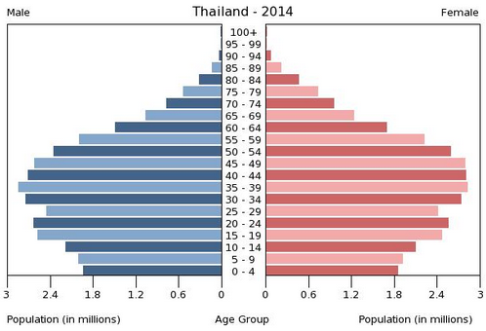
Data source: CIA World Factbook (2011 Estimate)
Appendix 2 – Political Economy
Figure 2.1
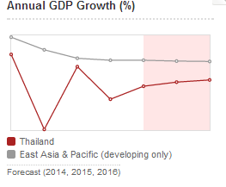
Data source: World Bank 201

Figure 2.2
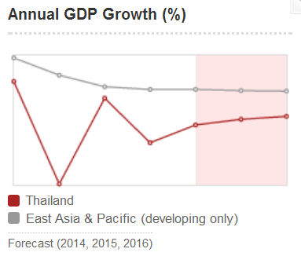
Data source: World Bank 2014
Figure 2.3
Data source: “Thailand.”, CIA: The World Factbook. 2014

Figure 2.4
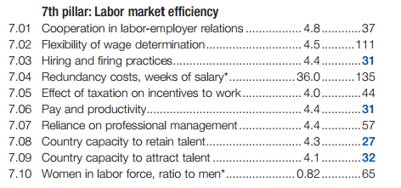
Data source: Schwab, Klaus and Xavier Sala-i-Martin 2014

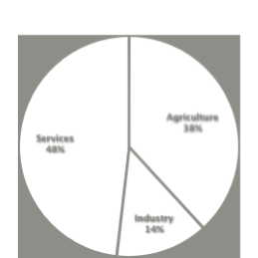Figure 2.5

Data source: “Thailand.”, CIA: The World Factbook. 2014

Figure 2.6
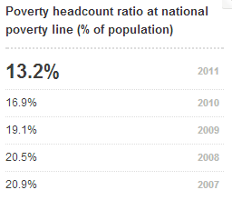
Data source: World Bank 2014

Figure 2.7
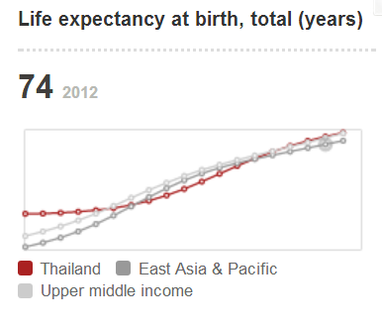
Data source: World Bank 2014

Figure 2.8
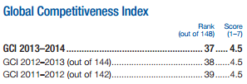
Data source: Schwab, Klaus and Xavier Sala-i-Martin 2014

Figure 2.9
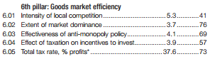
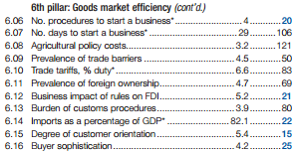
Data source: Schwab, Klaus and Xavier Sala-i-Martin 2014

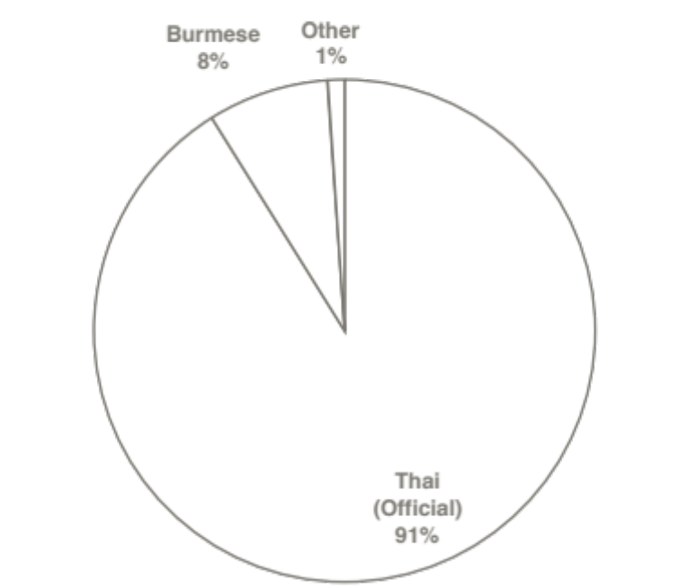Figure 2.10

Data source: Schwab, Klaus and Xavier Sala-i-Martin 2014

Appendix 3 – Cultural Characteristics

Figure 3.1

Data source: “Thailand.”, CIA: The World Factbook. 2014

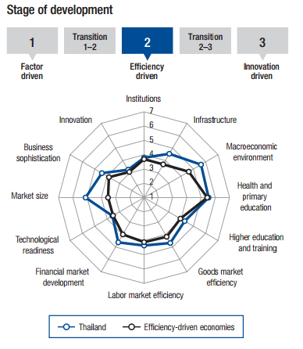

Figure 3.2

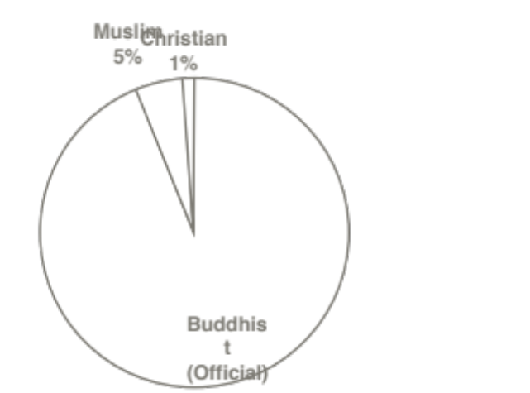Data source: “Thailand.”, CIA: The World Factbook. 2014

Figure 3.3
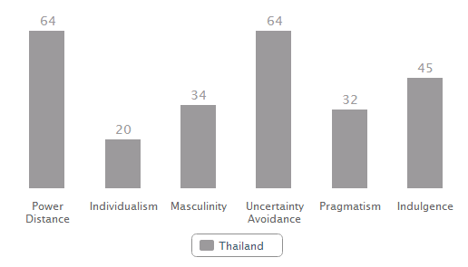
Data source: The Hofstede Center 2014

Appendix 4 – Company versus Country Ethics
Figure 4.1
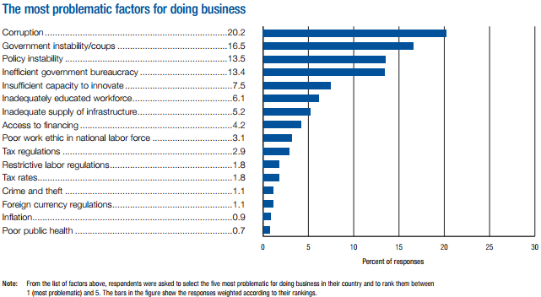
Data source: Schwab, Klaus and Xavier Sala-i-Martin 2014

Appendix 5 – Currency: Exchange Rate & Risk
Figure 5.1
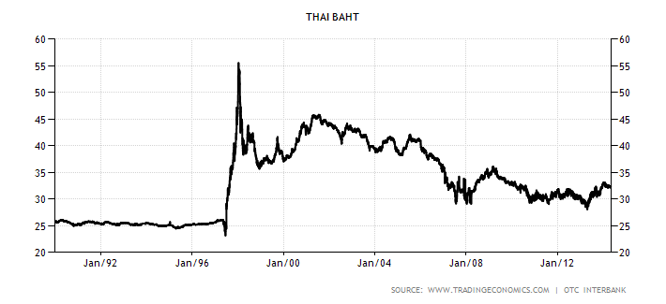
Data source: Trading Economics, “Thai Baht” 2014

Figure 5.2 – Currency Rate 10 Year
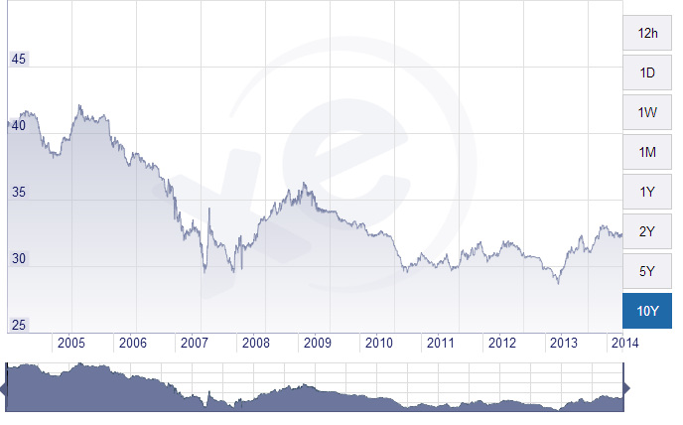
Data source: XE Trade, “XE Currency Charts – 10 Year” 2014
Figure 5.3 – Currency Rate 5 Year
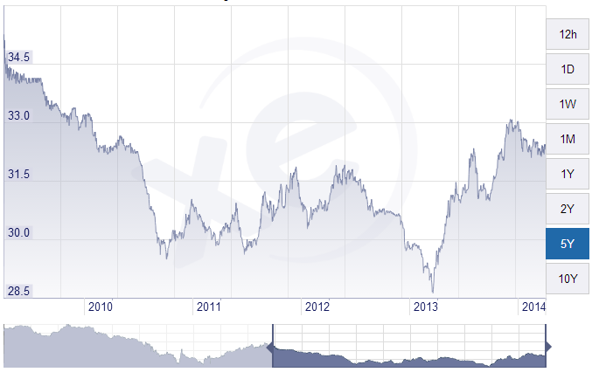
Data source: XE Trade, "XE Currency Charts – 5 Year” 2014
Figure 5.4
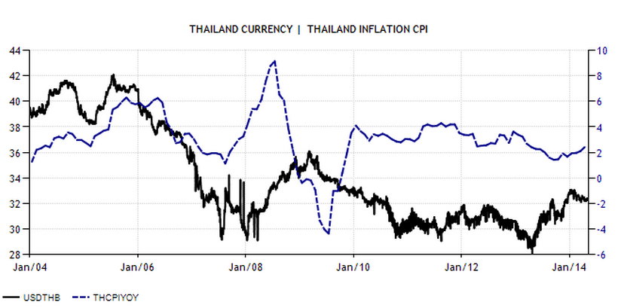
Data source: Trading Economics, “Thailand Currency – Thailand Inflation CPI” 2014

Figure 5.5
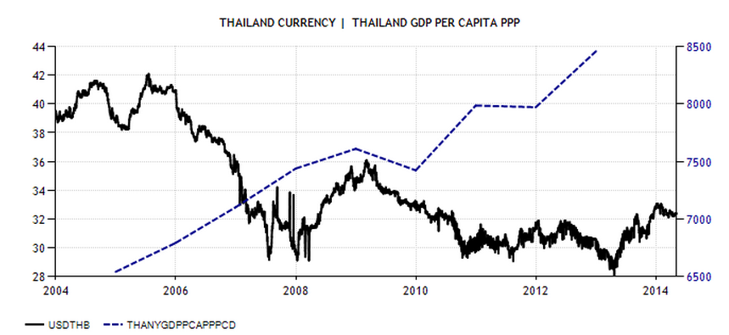
Data source: Trading Economics, “Thailand Currency – Thailand GDP Per Capita PPP” 2014

Figure 5.6

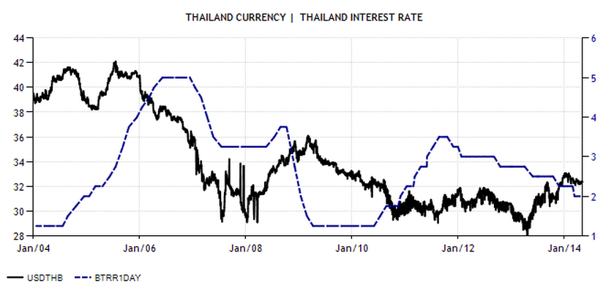Data source: Trading Economics, “Thailand Currency – Thailand Interest Rate” 2014.

Appendix 6 – MWBH’s Business Strategy

Figure 6.1

Data source: Hill 2014, p. 349

Figure 6.2
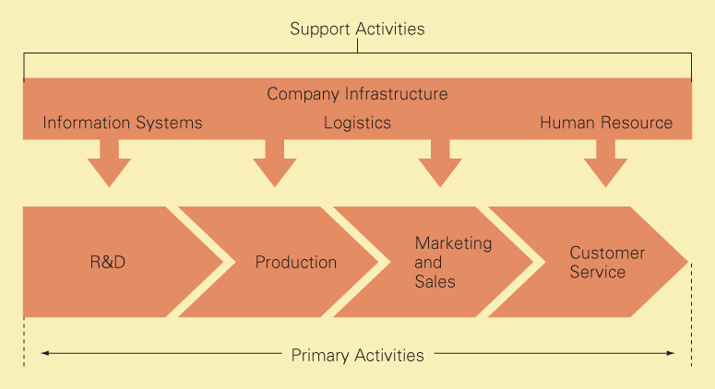
Data source: Hill 2014, p. 338
References
Food and Agriculture Organization of United Nations, Forestry Department. WOOD
Gannon, Martin J. and Rajnandini Pillai. 2010. “The Thai Kingdom.” Understanding Global Cultures: Metaphorical Journeys Through 29 Nations, Clusters of Nations, Continents, and Diversity. Thousand Oaks, Calif: SAGE, 25-34.
Hill, Charles W. L. "The Strategy of International Business." In Global Business Today. 8th ed. New York: McGraw-Hill Irwin, 2014.
“Internet Retailing in Thailand.” Retailing: Country Report. Euromonitor International. July 2013. http://www.euromonitor.com/internet-retailing-in-thailand/report.
Mujtaba, Bahaudin G., Ping Han, and Jieqiong Cao. 2013. "A Cross-Cultural Analysis of Management Skills of Chinese, Iranian, Pakistani, Thai, and American Managers." SAM Advanced Management Journal (07497075) 78, no. 1: 50-67.
"Murphy Bed Buyers Guide." Wall Beds and Wood Murphy Beds. Old Creek Company Wall Bed Factory, 2012. http://www.wallbedfactory.com/murphy-bed-buyers-guide/.
National Statistics Office, Thailand. “Executive Summary: The 2010 Population and Housing Census.” 2010 .http://popcensus.nso.go.th/upload/census-report-6-4-54-en.pdf
Powell, Larry, Jonathan Amsbary, and Mark Hickson. 2014. "The Wai in Thai Culture: Greeting, Status-Marking and National Identity Functions." Journal of Intercultural Communication no. 34: 7.Communication & Mass Media Complete.
PROCESSING. FAO Corporate Document Repository, 2013. http://www.fao.org/docrep/w7715e/w7715e08.htm
Schwab, Klaus and Xavier Sala-i-Martin. “The Global Competitiveness Report 2013-2014: Full Data Edition.” World Economic Forum. 2013. http://www3.weforum.org/docs/WEF_GlobalCompetitivenessReport_2013-14.pdf “Thailand.”
The Hofstede Center. 2014. http://geert-hofstede.com/thailand.html.
“Thailand.” CIA: The World Factbook. 2014. https://www.cia.gov/library/publications/the-world- factbook/geos/th.html.
“Thailand: Government.” 2014. Global Edge Michigan State University. http://globaledge.msu.edu/countries/thailand/history
“Thailand: History.” 2014. Global Edge Michigan State University. http://globaledge.msu.edu/countries/thailand/government
“Thailand Market Profile.” 2013. Export.gov: Helping US Companies Export. http://export.gov/thailand/doingbusinessinthailand/
Trading Economics. "Thai Baht." Trading Economics. 2014 http://www.tradingeconomics.com/thailand/currency.
Trading Economics. "Thailand Currency - Thailand Interest Rate.” 2014. http://www.tradingeconomics.com/charts/thailand- currency.png?s=usdthb&d1=20040101&d2=20141231&URL2=/thailand/interest- rate&type=line&title=THAILAND%20CURRENCY%20|%20%20THAILAND%20INTEREST%2 0RATE.
Trading Economics. "Thailand Currency - Thailand GDP Per Capita PPP." 2014. http://www.tradingeconomics.com/charts/thailand- currency.png?s=usdthb&d1=20040101&d2=20141231&URL2=/thailand/gdp-per-capita- ppp&type=line&title=THAILAND%20CURRENCY%20|%20%20THAILAND%20GDP%20PER %20CAPITA%20PPP.
Trading Economics. “Thailand Currency – Thailand Inflation.” 2014. http://www.tradingeconomics.com/charts/thailand- currency.png?s=usdthb&d1=20040101&d2=20141231&URL2=/thailand/inflation- cpi&type=line&title=THAILAND%20CURRENCY%20|%20%20THAILAND%20INFLATION% 20CPI.
Triamanuruck, Ngamnet; Sansanee Phongpala, and Sirikanang Chaiyasuta. "Overview of Legal Systems in the Asia-Pacific Region: Thailand." 2004. http://scholarship.law.cornell.edu/lps_lsapr/4UNICEF.
“Thailand – Statistics.” 2013. http://www.unicef.org/infobycountry/Thailand_statistics.html
XE Trade. “Thai Baht History.” http://www.xe.com/currency/thb-thai-baht
XE Trade. "XE Currency Charts – 5 Year." XE.com. 2014. http://www.xe.com/currencycharts/?from=USD&to=THB&view=5Y
XE Trade. "XE Currency Charts – 10 Year." XE.com. 2014. http://www.xe.com/currencycharts/?from=USD&to=THB&view=10Y
World Bank. “Thailand - Overview.” 2014. http://www.worldbank.org/en/country/thailand/overview

